Q1
%GIVEN
m=0.12;
T=0.20;
Xm=0.085;

% Required
% a) Fmax=?
% b) Spring constant=k=?

%SOLUTION:
% a) Maximum Force =Fmax=?
f=1/T;
omega=2*pi*f;
a=Xm*omega^2;
Fmax=m*a;
disp(Fmax);

%b) Spring constant =k=?
k=omega^2*m;
disp(k);

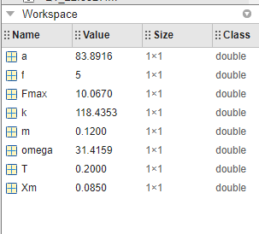

Q2
%GIVEN
m=2;
Us=2;%from graph
v=0.85;
x=0.15;
KE=1/2*(m*v^2);

%Required
% (a) If the particle passes through the equilibrium position with a
% velocity of 85 cm/s, will it be turned back before it reaches x = 15 cm?

% (b)If yes, at what position, and if no, what is the speed of the particle at x = 15 cm?

%SOLUTION
%At x=10cm we can see that U=0.5 from graph . Then
U1=0.5;
x1=10;
b=U1/x1^2;

%So at KE , Displacement is
Xm=sqrt(KE/b);
% so Xm =12.02
%(a) Since the particle mass doesn't reach X=15cm so it will not turn back at x=15cm
%(b) since it hasn't reached x=15cm and turn backs at x=12cm so velocity can't be found

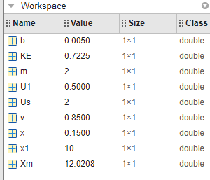

Q3
%GIVEN
b=0.070;
k=85;
m=0.25;
% Required
%(a) Time Period =T=?
%(b) t=? when 1/2Xm
%(c) t=? at 1/2(1/2kXm^2)

%Solution:
%(a)
T=2*pi*sqrt(m/k);
disp(T);

%(b)The amplitude at time t is displayed as xm e^(−bt/2m).
% According to given condition
% Xm e^−bt/2m = 1/2Xm
% e(-bt/2m)=1/2
% ln( e(-bt/2m))=ln(1/2)
% -bt/2m=ln(1/2)
t1=log(1/2)*2*m/(-b);
disp(t1);

%(c)the mechanical energy at time t is 1/2kXm^2 *e^(−bt/m).
% At t=0 , mechanical energy is 1/2kXm^2
% so according to given condition
% 1/2*kXm^2 e^−bt/m=1/2*(1/2kXm^2)
% cancelling same terms from both sides that is 1/2 kXm^2
% e^(-bt/m)=1/2
% ln( e(-bt/m))=ln(1/2)
% -bt/m=ln(1/2)
t2=log(1/2)*m/(-b);
disp(t2);

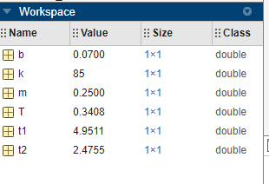

Q4
%GIVEN
m=2;
k=100;
t1=1;
x1=0.129;
v1=3.415;

%Required
%(a) Xm=? at t=1
%(b) Amplitude=Xm=? at t=0
%(c) velocity=v=? at t=0

%SOLUTION
%(a)
omega=sqrt(k/m);
phi=(atan(-v1/(omega*x1)))-omega*t1;
Xm=x1/cos(omega*t1+phi);
disp(Xm);

%(b) at t=0 amplitude is
X=Xm*cos(omega*0+phi);
disp(X);

%(c) at t=0 velocity is
v=-omega*Xm*sin(omega*0+phi);
disp(v);
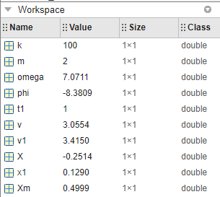’

Q5

%GIVEN
m=0.25;
k=85;
b=0.070;
e=2.71828;
%Required
%Ratio of oscillation amplitude at the end of 20 cycles to initial
%oscillations amplitude

%SOLUTION
T=2*pi*sqrt(m/k);
t=20*T;
% ratio is
% Xf/Xi = Xm*e^(-bt/2m)*cos(omega*t+phi) / Xm*cos(omega*t+phi)
%cancelling same terms
ratio= e^(-b*t/(2*m));
disp(ratio);

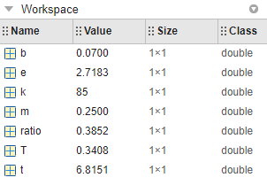

THANK YOU

